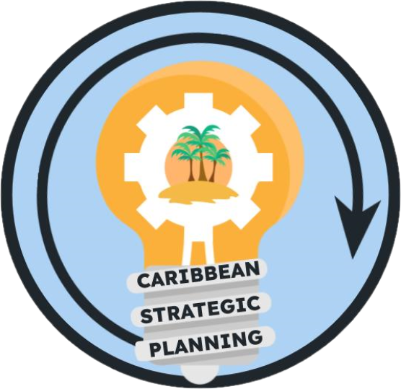Team Charter

Project: Develop FD data gap team to develop and prioritize data inventory

**Purpose**

Our purpose is to discover and inventory all known commercial and recreational fishery dependent data collections, including historical and ongoing, in the U.S. Caribbean as well as elsewhere in the Caribbean region for certain species and use the inventory to identify gaps for prioritization in terms of expansion or implementation of data collections critical to stock assessment improvement.

**Goals**

Our goals are:

1. Review previous efforts that identified FD data sources.
2. Develop an inventory format that identifies the information we want to know about each data source (what was collected, who collected it, when was it collected, etc.)
3. Develop a survey to identify collections and identify persons who should be targeted by the survey. Other CSP (CSP= Caribbean Strategic Planning) working groups should be involved in this process.
4. Establish inventory as a living worksheet on Google Drive, with an intention to later house the inventory on some other platform such as SEFSC ODM (Online Data Management), ACCSP Bio-inventory, or Caribbean Regional collaborative knowledge hub.
5. Establish a process to move information identified in 1-3 into the worksheet described in 4.
6. In conjunction with other CSP working groups, identify and prioritize gaps

Our ideal outcomes are to produce an inventory and metadata that enables visualization of data gaps and actionable recommendations to fill these gaps.

The deliverables will be:

1. A living inventory of Caribbean Fishery Dependent data sources.
2. A final report out presentation to the CSP members.
3. Training sessions for stakeholders on how to access and add to the inventory.
4. A brief written final report for documentation that includes prioritization of FD data needs. Suggest inclusion as an InPort entry.

**Team**

* *Lead*: Larry Beerkircher
* *Members*: Daniel Matos, Todd Gedamke, Grisel Rodriguez, Refik Orhun, David Behringer
* *Stakeholders*: CFMC, CIMAS, DRNA, DPNR, EBFM TAP, NOAA HQ, NPS, PRSG, QM/CI PSG, SEFSC, SERO, SSC, UPR, USC-A, UVI
* *KSAs*: The team has a strong background in FD data in general and in the U.S. Caribbean specifically. Potential weakness is lack of a U.S. Virgin Island team member. Team should identify liaisons with other CSP Project Teams (Data Appropriate Methods/Toolbox, Life History Data Gaps, and Socioeconomic Data Gaps Teams) to help achieve the desired outcome (actionable recommendations) as well as leverage overlapping effort (Life History and Socioeconomic Data have FD components).

**Team Process**

* Meeting day/time: Third Wednesday of every month, 1-2:30 pm
* Meeting frequency: Monthly
* Decision-making procedures: Consensus
* Team communication: Google Meet for standing or any ad-hoc meetings, group emails for routine communications between meetings, and comments in working drafts placed in the team google drive folder.

**Team Norms**

* *Values*:
  + Integrity, reproducibility, transparency, and communication of data
  + Innovation through adaptive management and continuous improvement
  + Respect and trust in data and partnerships
  + Diversity and inclusivity of data sources, data input, communities, and stakeholder ideas
  + Collaboration and cooperation in the collection and dissemination of data
* *Agreements*: The Team agrees to work in an environment of mutual respect where all Team Members will be given an opportunity and encouraged to present ideas and viewpoints. Hand raising will not be needed during google meets as long as team members do not talk over each other.

**Supporting Resources**

* *Google Drive folder*: [Working Groups](https://drive.google.com/drive/folders/1GR0WWtq_eOGT89s0n8p1imwZ1ntcnczN)
* *Project facilitation*: Rachel Banton (rachel.banton@noaa.gov)
* *Process facilitation*: Richard Maclin, Vivian Matter (vivian.matter@noaa.gov), Jenny Suter (jenny.suter@noaa.gov)

**Metrics**

Success will be measured by a document that prioritizes the FD data needs